Customized solutions of AIPPOW’s high power mobile charge systems：

1. 360KW-6MW charge range.
2. 1MWH-6MWH ESS container capacity.
3. 3000A MAX charge current.
4. high C rate LFP battery tech support fast charge and discharge working mode.
5. -50℃--60℃ working temperature.
6. UL version are available.
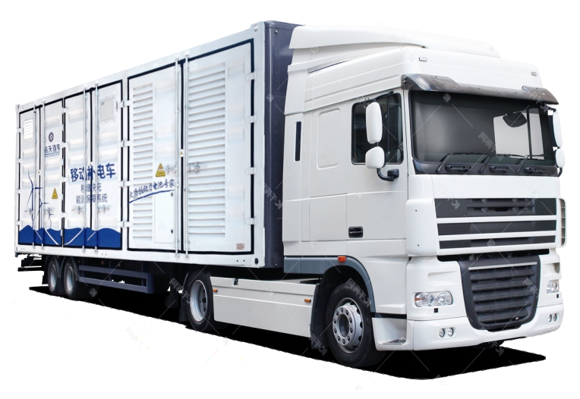

AIPPOW’s High-power mobile charging systems are frequently needed in applications where heavy-duty electric vehicles (HDVs) or equipment operate in remote, high-demand, or time-sensitive environments.

Below are the key applications:

Mining Industry
Application: Charging electric haul trucks, loaders, and auxiliary vehicles in remote mining operations.
Why It's Needed
- Mining equipment operates continuously and often in remote areas with limited infrastructure.
- High-power mobile chargers provide rapid charging to reduce downtime and ensure uninterrupted operations.

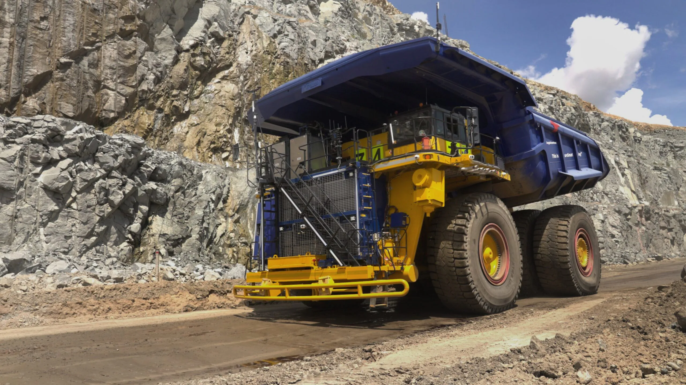

Construction and Infrastructure Projects
Application: Charging electric excavators, cranes, and other heavy construction machinery on-site.
Why It's Needed:
- Construction sites are often temporary and lack permanent charging infrastructure.
- Mobile chargers ensure machines remain operational without requiring relocation for charging.

Ports and Shipping Terminals
Application: Charging electric cranes, forklifts, container handlers, and other port equipment.
Why It's Needed:
- Port operations require high uptime for efficiency, and mobile charging supports equipment without disrupting workflows.
- Mobile systems allow flexibility to charge equipment at different docking stations or terminal locations.

Remote Renewable Energy Sites
Application: Charging electric vehicles and equipment at wind or solar farm construction or maintenance sites.
Why It's Needed
- Renewable energy projects are often in remote areas with limited grid access.
- High-power chargers keep electric tools, vehicles, and maintenance equipment operational.
_ The mobile ESS chargers can also storage and transport the extra electricity form the wind or solar farm to where is lack of electricity.

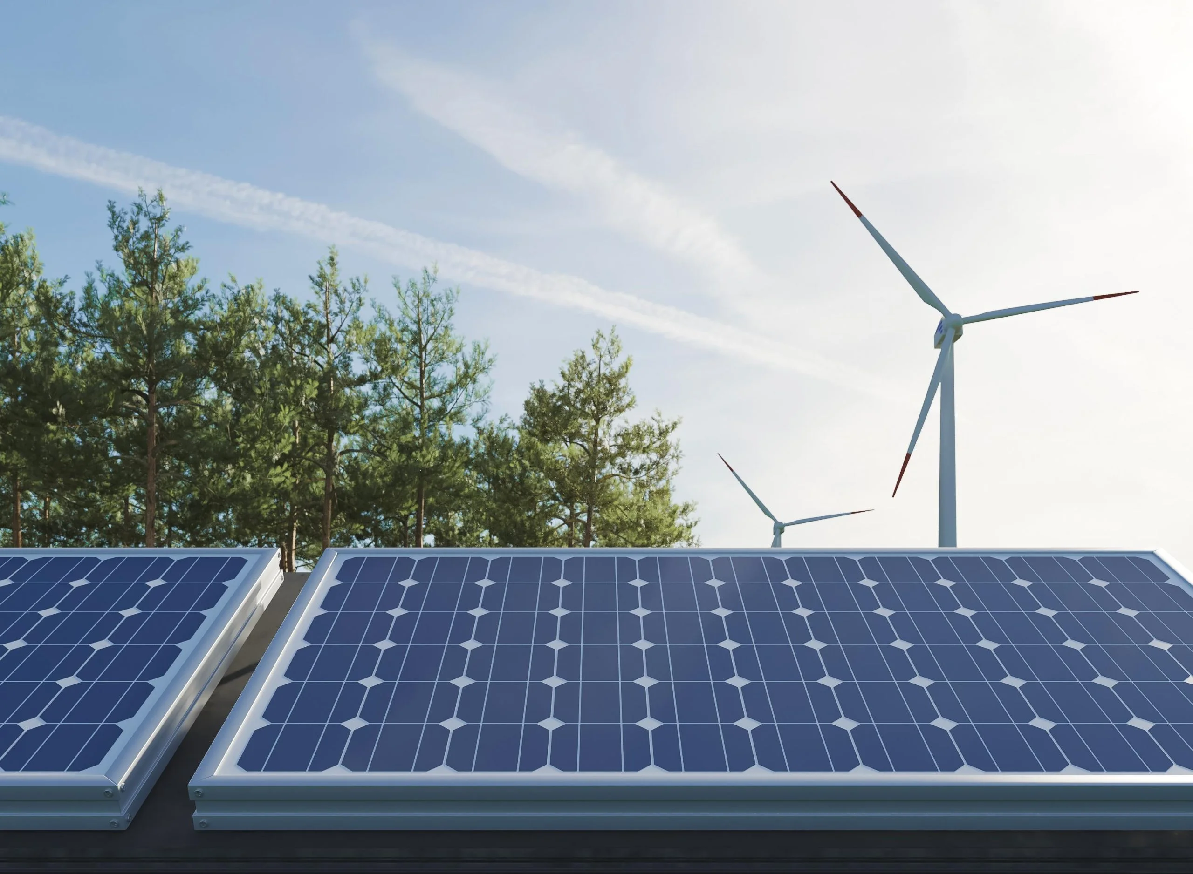

Military Operations
Application: Charging electric military vehicles, drones, or auxiliary power units in the field.
Why It's Needed
- Military deployments require flexible, mobile charging solutions for tactical vehicles and equipment.
- High-power chargers ensure readiness in remote or unpredictable locations.

Emergency and Disaster Response
Application: Supporting electric rescue vehicles, mobile command centers, or temporary power stations.
-Why It's Needed:
- Disaster zones often lack stable grid access, and high-power mobile chargers provide critical support for electric-powered operations.
- Enables rapid deployment and recharge of equipment during emergencies.

Agriculture and Forestry
Application: Charging electric tractors, harvesters, and forestry equipment.
Why It's Needed:
- Farms and forestry operations are frequently in off-grid or rural locations.
- Mobile chargers provide flexibility for charging in fields or forested areas.

Public Transportation and Fleets
Application: Charging electric buses, delivery vans, and logistics trucks during off-route stops.
Why It's Needed
High-power mobile chargers allow fleets to recharge between routes, ensuring minimal disruption to operations.

Logistics and Warehousing
Application: Charging electric forklifts, transport trucks, and warehouse automation equipment.
Why It's Needed
- Warehousing operations require flexibility for mobile equipment, and high-power chargers ensure vehicles can recharge without interrupting workflows.

Events and Temporary Installations
Application: Charging electric vehicles and equipment for outdoor events, expos, or pop-up installations.
- **Why It's Needed**:
- Events often lack permanent charging infrastructure, and mobile chargers provide rapid and flexible power solutions.

